Title of the Paper

**First Author1)[1], Second Author2), Third Author3)**

|  |
| --- |
| *Abstract*  **Background:** What is the latest knowledge on the issue? Some key phrases to use here are: recent studies/although some clinical research has established x, the role of y is not well known.  **Objective:** What did you want to find out? Some key phrases to use here are: This study examines/To ascertain/To identify/To understand  **Methods:** How did you go about finding it? What type of methodology did you use? A quantitative study/a randomized controlled study/a qualitative survey/a literature review/a double blind trial  **Results:** What did you find? What data or outcomes did you observe? You can use phrases such as X was observed because of Y. Do not be vague! State exactly what you found.  **Conclusion:** What did your results tell you? Did you find out what you wanted? Why or why not? What should be studied next? Use phrases such as X was statistically significant, Variable A has a negative correlation with Variable B, etc.  ***Keywords:***Keyword 1, Keyword 2, Keyword 3, Keyword 4, Keyword 5, Keyword 6  ***Article history:***Received 16 May 20XX, Revised 3 April 20XX, Accepted 8 April 20XX, Available online 30 April 20XX |

# Introduction

This template provides authors with most of the formatting specifications needed for preparing electronic versions of their papers for *Journal of Information Systems Engineering and Business Intelligence*. All standard paper components have been specified for three reasons: (1) ease of use when formatting individual papers, (2) automatic compliance to electronic requirements that facilitate the concurrent or later production of electronic products, and (3) conformity of style throughout a journal publication. Generally, a typical paper contains between 3000 and 6000 words, but there are no rigorous restrictions. Margins, column widths, line spacing, and type styles are built-in; examples of the type styles are provided throughout this document. The main sections (headings) include Introduction, Literature Review (optional), Methods, Result, Discussion, and Conclusion. Use sub-heading accordingly, the maximum depth of the subheading is Subheading 3.

Introduction section can include background information such as theories, prior work, and hypotheses. This is followed by a statement of the purpose of the research issue or problem and/or set of questions you attempt to answer in your research.

# Literature Review (Optional)

A literature review is a critical, analytical summary and synthesis of the current knowledge of a topic. It should compare and relate different theories, findings, and so on, rather than just summarize them individually. It should also have a particular focus or theme to organize the review. The length of this section is between 300 – 600 words.

# Methods

The methods sections often come disguised with other article-specific section titles, but serve a unified purpose: to detail the methods used in an objective manner without introduction of interpretation or opinion. The methods sections should tell the reader clearly how the results were obtained. They should be specific. They should also make adequate reference to accepted methods and identify differences.

# Results

The results section and the following discussion section allow the most flexibility in terms of organization and content. In general, the pure, unbiased results should be presented first without interpretation. These results should present the raw data or the results after applying the techniques outlined in the methods section. The results are simply results; they do not draw conclusions.

The main purpose of the results section is to provide the data from the study so that other researchers can draw their own conclusions and understand fully the basis for the conclusions. A common format for the results section is to present a series of figures and to describe the figures in detail through the text. A good results section presents clear figures with efficient text. The figures should support the assertions in the paper or illustrate the new insights. Where applicable, results should be illustrated in terms of non-dimensional variables.

## Figure

All figures should be numbered with Arabic numerals (1,2,3,….). Every figure should have a caption. All photographs, schemas, graphs and diagrams are to be referred to as figures. Line drawings should be good quality scans or true electronic output. Low-quality scans are not acceptable. Figures must be embedded into the text and not supplied separately. In MS word input the figures must be properly coded. Preferred format of figures are PNG, and JPEG. Lettering and symbols should be clearly defined either in the caption or in a legend provided as part of the figure. Figures should be placed at the top or bottom of a page wherever possible, as close as possible to the first reference to them in the paper. Please ensure that all the figures are of 300 DPI resolutions as this will facilitate good output.

The figure number and caption should be typed below the illustration in 8 pt and left justified [Note: one-line captions of length less than column width (or full typesetting width or oblong) centered]. Artwork has no text along the side of it in the main body of the text. However, if two images fit next to each other, these may be placed next to each other to save space. For example, see Fig. 1.

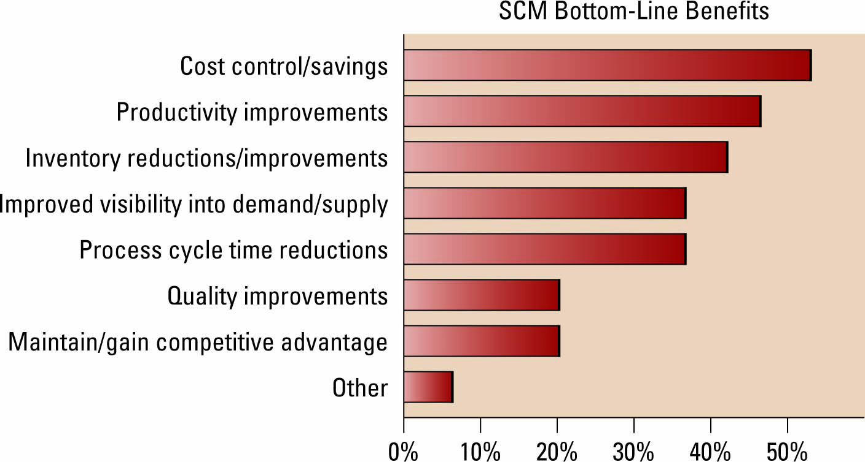

Fig. 1 Caption for figure

## Table

All tables should be numbered with Arabic numerals. Every table should have a caption. Headings should be placed above tables, left justified. Only horizontal lines should be used within a table, to distinguish the column headings from the body of the table, and immediately above and below the table. Tables must be embedded into the text and not supplied separately. Table 1 is an example which the authors may find useful.

TABLE 1

The significance of The Relationships in The Model

|  |  |  |  |  |  |
| --- | --- | --- | --- | --- | --- |
| Relationships | Original Sample (O) | Sample Mean (M) | Standard Deviation (STDEV) | T Statistics (|O/STDEV|) | P Values* |
| Perceive Ease of Use ->Attitude | 0,286 | 0,288 | 0,058 | 4,907 | 0,000 |
| Information Quality ->Intention to Use | 0,175 | 0,174 | 0,072 | 2,434 | 0,015 |
| Information Quality ->User Satisfaction | 0,299 | 0,294 | 0,076 | 3,924 | 0,000 |
| Intention to Use ->Use | 0,657 | 0,658 | 0,039 | 17,054 | 0,000 |
| Use ->Net Benefits | 0,463 | 0,461 | 0,061 | 7,576 | 0,000 |
| Use ->User Satisfaction | 0,405 | 0,400 | 0,068 | 5,936 | 0,000 |
| Perceive Usefulness ->Attitude | 0,455 | 0,455 | 0,056 | 8,058 | 0,000 |
| **Performance Expectancy -> Intention to Use** | 0,052 | 0,053 | 0,058 | **0,893** | **0,372** |
| **Service Quality -> Intention to Use** | 0,065 | 0,068 | 0,072 | **0,905** | **0,366** |
| Service Quality ->User Satisfaction | 0,167 | 0,177 | 0,068 | 2,474 | 0,013 |
| Social Influence ->Intention to Use | 0,263 | 0,263 | 0,061 | 4,302 | 0,000 |
| **System Quality -> Intention to Use** | -0,008 | -0,005 | 0,076 | **0,107** | **0,915** |
| **System Quality -> User Satisfaction** | 0,065 | 0,066 | 0,072 | **0,904** | **0,366** |
| Attitude ->Intention to Use | 0,337 | 0,331 | 0,075 | 4,488 | 0,000 |
| User Satisfaction ->Net Benefits | 0,428 | 0,430 | 0,059 | 7,207 | 0,000 |

*alpha=0.05

## Equations

Equations and formulae should be typed in Mathtype or any Equation Editor, and numbered consecutively with Arabic numerals in parentheses on the right hand side of the page (if referred to explicitly in the text). They should also be separated from the surrounding text by one space.

       

Be sure that the symbols in your equation have been defined before or immediately following the equation. Use “(1),” not “Eq. (1)” or “equation (1),” except at the beginning of a sentence: “Equation (1) is ...”

### Figure

Example of Subheading 3. This is maximum depth of the subheading.

# Discussion

The discussion section is where the article interprets the results to reach its major conclusions. This is also where the author’s opinion enters the picture. The discussion is where the argument is made. Common features of the discussion section include comparison between measured and modelled data or comparison among various modelling methods, the results obtained to solve a specific engineering or scientific problem, and further explanation of new and significant findings.

# Conclusions

The conclusion contains a summary of what is learned from the results obtained, what needs to be improved in further study. Other common features of the conclusions are the benefits and applications of the research, limitation, and the recommendations based on the results obtained.

References

Please use IEEE standard for Reference style. We suggest there should be at least 20 references within the manuscript. Make sure you use Mendeley feature in Microsoft Word for handling citation in manuscript. References may not include all information; please obtain and include relevant information. Do not combine references. There must be only one reference with each number. If there is a URL included with the print reference, it can be included at the end of the reference.

The template will number citations consecutively within brackets [1]. The sentence punctuation follows the bracket [2]. Refer simply to the reference number, as in [3]—do not use “Ref. [3]” or “reference [3]” except at the beginning of a sentence: “Reference [3] was the first ...”.

1. G. Eason, B. Noble, and I.N. Sneddon, “On certain integrals of Lipschitz-Hankel type involving products of Bessel functions,” Phil. Trans. Roy. Soc. London, vol. A247, pp. 529-551, April 1955. (*references*)
2. J. Clerk Maxwell, A Treatise on Electricity and Magnetism, 3rd ed., vol. 2. Oxford: Clarendon, 1892, pp.68-73.
3. I.S. Jacobs and C.P. Bean, “Fine particles, thin films and exchange anisotropy,” in Magnetism, vol. III, G.T. Rado and H. Suhl, Eds. New York: Academic, 1963, pp. 271-350.
4. K. Elissa, “Title of paper if known,” unpublished.
5. R. Nicole, “Title of paper with only first word capitalized,” J. Name Stand. Abbrev., in press.
6. Y. Yorozu, M. Hirano, K. Oka, and Y. Tagawa, “Electron spectroscopy studies on magneto-optical media and plastic substrate interface,” IEEE Transl. J. Magn. Japan, vol. 2, pp. 740-741, August 1987 [Digests 9th Annual Conf. Magnetics Japan, p. 301, 1982].

1. Corresponding author